Fungifama
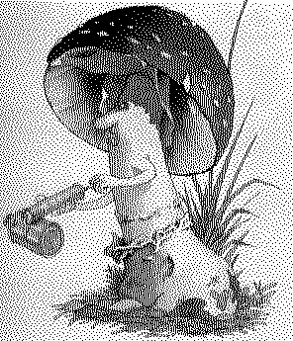

The Newsletter of the South Vancouver Island Mycological Society
April 2005

President
Christian Friedinger 250-721-1793
Vice-President
Jennifer English 250- 656-3443
Past-President
Christine Roberts 250-478-2976
Treasurer & Membership & Subscriptions
Jean Johnson 250-656-3117
2552 Beaufort Rd., Sidney, BC V8L 2J9
jeanwade@islandnet.com
Refreshments Organiser
Gerald & Marlee Loiselle 250-474-4344
Tineke Van der Voort 250- 743-3686
Foray Organizers
Adolf & Oluna Ceska 250-477-1211
Fungifama Editor
Shannon Berch 250-652-5201
shannonberch@telus.net
Directors-at-large
Richard Winder 250-642-7528
Kevin Trim 250-642-5953
Webmaster
Ian Gibson 250-384-6002
ig@islandnet.com
SVIMS list serve master
Adolf Ceska adolf@victoria.tc.ca
To broadcast a message to SVIMS members via email: svims-l@victoria.tc.ca
SVIMS web site: www.svims.ca
Dues: $20.00 per year per household, payable in January by cheque made out to SVIMS or by cash at meeting.
Meetings: First Thursday of the month (no meetings December, January, July, and August), 7:00 p.m. sharp at the Pacific Forestry Centre, 506 Burnside Rd W, Victoria. Lots of free parking. The meeting room is near the main entrance door. Non-members welcome.
Caution: The South Vancouver Island Mycological Society (SVIMS) newsletter, Fungifama, is not intended as an (online) identification or medicinal guide to mushrooms. There are risks involved in eating and in using wild mushrooms. The possibility may exist that you are allergic to a specific mushroom, or that the mushroom may be anomalous. SVIMS, Fungifama and the authors on this site warn that the reader must accept full personal responsibility for deciding to use or consume any particular specimen.
Monthly Meetings:

April 7: Russulas of southern Vancouver Island coastal forests
Speaker – Christine Roberts

May 5: Morel Ecology
Speaker – Michael Keefer or Richard Winder

June 2: Possible potluck supper and video ‘Attack of the Mushroom People’. Details to follow…

Prez Sez
By Christian Friedinger
Oyster Mushrooms, the Farmer’s Best Friend
Nitrogen deficiency is a very serious agricultural problem. Most crops use up nitrogen and compensation with a nitrogen-producing crop cycle (beans etc.) is not always possible. Conventional remedies are nitrogen fertilizer or moving to new ground... Moreover, nitrogen is also tied up, at least temporarily, when bacteria decompose plowed-under straw, canes etc. from previous crops. Composting these “woody” materials does not solve the immediate problem because it is time and energy consuming.
The mycelium of Pleurotus (Oyster mushrooms) offers an interesting alternative. By growing mycelium on those materials (straws, corncobs, maze, canes, seed hulls etc.), they are broken down quickly and with a positive balance (biologically and financially!) - a crop of nutritious mushrooms. And the ‘leftovers’ are usable as feed for cattle, chickens and ultimately as soil improvements. The understanding of these biological processes is very important especially in the context of our oil-based food production.
We will have more detailed discussions about these topics in SVIMS meetings. For a practical experience of these processes, SVIMS is organizing an oyster mushroom growing workshop. Oyster mushrooms are already grown in large quantities primarily for human consumption; however the wider aspects that concern agricultural revitalization and sustainable production seem to be even more important. Very informative is Paul Stamets book “Growing Gourmet & Medical Mushrooms”.

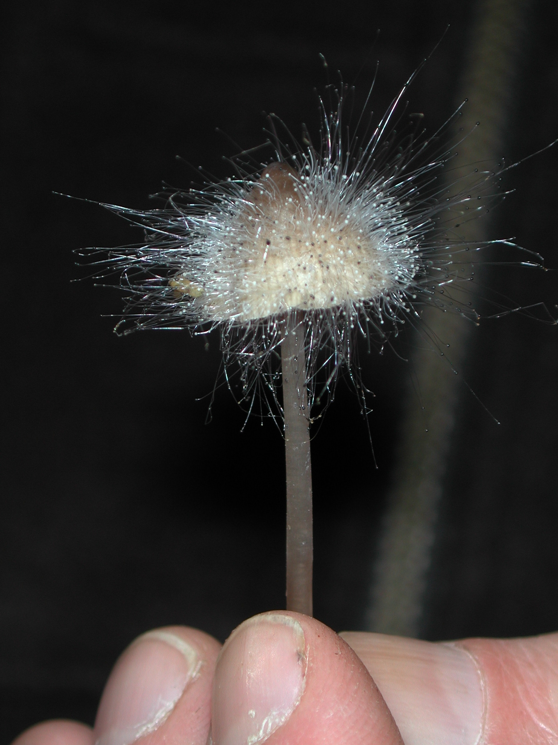
Mucor species growing on Mycena species, Robson Valley, BC

Events and Forays:

North American Mycological Association (NAMA) foray
• July 21-24, 2005
• University of Wisconsin-La Crosse
http://botit.botany.wisc.edu/toms_fungi/NAMA2005.html
Written by Tom Volk, University of Wisconsin
A highlight of the 2005 NAMA foray will be the chance to see a forest of American chestnut trees (Castanea dentata). You probably know that almost all the chestnuts in Appalachia and other parts of eastern North America were wiped out (or reduced to understory plants) by Cryphonectria parasitica, cause of chestnut blight. However while all this was happening, circa 1900 a farmer from Pennsylvania planted 11 chestnut trees along the edge of his field. These 11 trees grew and multiplied to about 6000 (six thousand) trees larger than 5 inches diameter. These trees were free from chestnut blight until about 1988, when the blight appeared on a single tree. Despite control attempts by researchers from the Wisconsin DNR, West Virginia University, and Michigan State University, the blight has continued to spread, and now about 1500 of these trees have died, although some parts of the forest remain largely uninfected. Inoculations of the trees with hypovirulent strains of the fungus have slowed it down, but trees are still dying. This may be your last chance to see a mature chestnut forest. The state record chestnut tree is about 4 ft diameter, and although it now has the blight, I hope it will still make it to July.
In addition to the forays, there will be many lectures and workshops by mycologists from all over North America and Europe. All levels of expertise will be accommodated, from beginners to intermediate to advanced. The Chief Mycologist and Guest Mycologists are uncertain at this point, but I will be the host mycologist. Stay tuned for further details.

Mexican Mushroom Tours – 2005
For Fungi Aficionados with a Taste for the Exotic
http://www.mexmush.com/index.htm
Gundi Jeffrey (Tour Organizer), Mexican Mushroom Tours
APDO #73, Tlaxcala, Tlax. 90000 Mexico
Tel/Fax: (246) 461-8829 (From US or Canada, first dial access: 011-52)
For our next season of organizing adventuresome mushrooming excursions in exciting Mexico, we have organized a new slate of tours, each offering unique travel, cultural and, of course, fungi experiences with expert local bilingual mycologists:
Copper Canyon, July 23 – 31, 2005
Tlaxcala, August 28-September 4, 2005
Veracruz, October 16 – 23, 2005
Numerous articles and stories about Mexican Mushroom Tours have appeared in various media ranging from club newsletters to The New York Times, which said our tour was "mushroom heaven." You can read some of these articles on our Articles Page or Contact Us for more information (see contact information above).

4th International Workshop on Edible Mycorrhizal Mushrooms
• November 29 – December 2, 2005
• Murcia, Spain
http://www.iwemm4.com/Inicio/Inicio.asp
The 4th IWEMM aims to provide a forum for discussion on currently available data and advances made in the technology for the culture of edible mushrooms (e.g. matsutake, boletes, chanterelles) and truffles, inoculum production, mycorrhization control, forest plantations, forest management techniques for improving mushroom or truffle production and their projection on rural development.

Mushroom of the Month
Submitted by Christine Roberts
Latin name: Russula murrillii
Common name: If I had to make one up I'd say purple chalky mushroom
Cap: Purple to lilac with blackish streaks, slimy,with a matte appearance under the slime as if it had been coloured in with pastels. About 4-7cm across
Stem: White, dry, about 4-5cm by 1.5-2.5cm, cylindrical or clavate, becoming hollow.
Gills: deep warm yellow when mature
Veil and or volva: none
Spore print colour: yellow
Odour and taste: mushroomy, taste mild, a bit sweet
Habitat and when found: Under Douglas fir, October to early December, lots in Royal Roads
Edibility: Not known but probably not toxic
Additional remarks: Once you have seen the cap texture it is fairly easy to recognize and very elegant.

Articles about fungi

Fungi control crop diversity
By Poulsen and Boomsma: Science
February 11, 2005
http://www.stri.org/english/about_stri/headline_news/publications/article.php?id=119
Former Smithsonian Tropical Research Institute fellow Michael Poulsen and visiting scientist Jacobus Boomsma, from the University of Copenhagen, published “Mutualistic fungi control crop diversity in fungus-growing ants” in Science (Feb 4, 307: 741-744). Leaf-cutting ants have been cultivating fungi for 50-60 millions years, but every colony raises only one particular crop. In this article, Poulsen and Boomsma explain how the different strains compete, forcing the ants to grow just one. Benefits of ant fungiculture are mutual. The leaf-cutting ants don’t eat the leaves. They carry them to their nest to feed this special fungus. As it grows, the fungus is fed to members of the colony, and is carried by virgin ant queens when they leave to mate and disperse.
Poulsen and Boomsma observed fungus gardens of 18 ant colonies cultivated by colonies of two sympatric species of leafcutting ants Atta echinatior and Atta octospinosus, collected in Gamboa from 1994 to 2002. “When they placed ant feces from one colony onto the fungus of another, the fungus became discolored and grew slower. In addition, when ants from one colony were fed fungi from another, their feces caused a similar reaction on their own fungi. This did not happen when they were fed fungus from their own garden. These findings led the researchers to suspect that compounds specific to the foreign fungus were inhibiting the growth of the in-house fungus. This makes it necessary that ants rear clones of the same fungi. Otherwise, the competition would stunt fungal growth and reduce the ants' food supply. So in terms of farming, it's really the fungus that's running the show.”

The Edible Psathyrellas of Haiti
http://home.att.net/~gyetter/djon.htm
In the Flatbush neighborhood of Brooklyn, New York, a mushroom from Haiti known by the Creole word for mushroom, "djon-djon," is a popular commodity. Quantities of djon-djon are sold in dried form by street vendors and in food markets along Church Ave. and Flatbush Ave., a few blocks from Prospect Park. The mushroom is the main ingredient along with garlic in "riz djon-djon," or "riz noir," a favorite Haitian rice dish.

NorthEast Mycological Federation Inc
Submitted by Jean Johnson
Check out this new Web site: www.nemf.org
Gary Lincoff's Beginners Page - an Advanced Page will be added in the very near future - includes a list of books every beginner should own, a list of mushrooms every beginner should know, and keys and instructions for their use and for making spore prints. Moreover, Gary has created a collection of pages for the website called "The Illustrated Mushroom Year" which shows the commonly found species in seasonal arrangements. In addition, there is information on mushroom dyes, photography, and mycophagy.

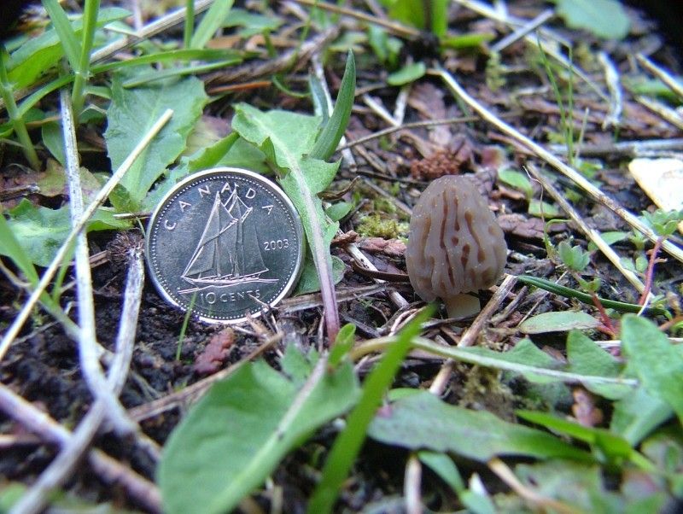
This picture was taken March 29 2005 by Kevin Trim in the Sooke area, who said “I'm not sure what to say about it other than: be careful where you step”.

Membership News
Welcome back member Christa Imhof.

Welcome new member Kem Luther.

