Fungifama
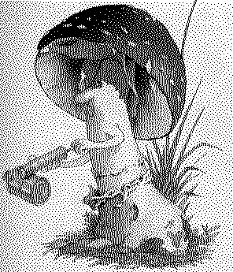

The Newsletter of the South Vancouver Island Mycological Society
August 2002

President John Dennis 250-595-7499

Vice-President Christine Roberts 250-478-2976

Treasurer & Membership & Subscriptions
Jean Johnson 250-656-3117
2552 Beaufort Rd., Sidney, BC V8L 2J9
jeanwade@islandnet.com

Refreshments Organiser
Al Witiuk 250-478-6678

Foray Organizers
Adolf & Oluna Ceska 250-477-1211

Fungifama Editor
Shannon Berch 250-652-5201
shannonberch@telus.net

Directors-at-large
Bernice Witiuk 250-478-6678
Diane Luong (Publicity) 250-382-8287
Justin Hodkinson 250-382-8287

Webmaster Rob Countess 250-902-0562

SVIMS web site: www.svims.ca

Dues: $15.00 per year per household, payable in January by cheque made out to SVIMS or by cash at meeting.

Meetings: First Thursday of the month (no meetings December, January, July, and August), 7:00 p.m. sharp at the Pacific Forestry Centre, 506 Burnside Rd. W., Victoria. Lots of free parking. The meeting room is near the main entrance door. Non-members welcome.

Monthly Meetings:

Thursday, September 5
OysterFest (mushrooms that is!). John Dennis will lead us through the 'how-to' of growing our own Oyster mushrooms.

Thursday, October 3
Mushrooms down under. Jean Johnson will thrill us with mushroom pictures taken during her recent trip to southern Australia and Tasmania.

Thursday, November 7
Mushroom Madness and NAMA video on Mushroom scents and Elections! Could it get any more exciting? Bring in mushrooms to be identified by the group. Learn some of the basics about identifying mushrooms. Become one of the SVIMS directors and make your mark on Victoria area mycophily.

December: no meeting

Survivors Banquet
Saturday, January 18, 2003 at the Horticulture Centre of the Pacific. Organized by Shannon Berch.

Events and Forays:

Swan Lake Mushroom Show
Sunday, October 20. Join us for pre-show collecting forays or volunteer to help at the show: setting up, taking down, selling goodies, helping with the kiddies corner, etc. Organized by Christine Roberts.

Cowichan Lake Foray
October 25, 26, 27 at the Cowichan Lake Education Centre (Mesachie Lake) - Organized by Jean Johnson

Horticulture Centre of the Pacific Foray November TBA - Organized by Shannon Berch

Prez Sez
It was a cool, wet, late spring. Please don't complain! These conditions make for a productive spring and summer wild mushroom harvest. By July, I had already picked Boletus barrowsii in 2 spots. I may have morel blindness, but I do seem to be able to find the Boletes. I know you can too.
If you didn't make it to the last couple of meetings, you missed some good ones. Swann Gardner's presentation on the mushroom growing cooperative was great. He had no props (slides, demonstration material, etc.) but I still had to "kick" everybody out of PFC because there were so many interested people asking him questions on the details of his work.
And what can I say about the 3-D mushroom presentation? They were so realistic that I wanted to pick them. Not only that, but the photos were beautiful and Fred Rhoades was very knowledgeable. I learned a lot about the mushrooms he photographed. And, yes, the polarized glasses made me look cool.
The last meeting had Renata Outerbridge making a presentation on her Ph.D. thesis work. Her talk also pointed out the great number of fungi that I probably don't even see or spend any time trying to identify. She explained their functions in the forest and gave us a better appreciation of how they benefit, not only the forests, but also mankind. I also learned how important it was to know the habitat of the fungi you want to find. For example, go to the western hemlock forests rather than western redcedar when you are looking for chanterelles.
The next SVIMS meeting is in September. It will be on growing oyster mushrooms. It won't be a lecture but a hands-on oyster mushroom inoculation fest. I have got a culture of Pleurotus growing on agar media and will inoculate jars or bags of grain. I hope to have enough jars so that those attending the meeting can inoculate some pre-sterilized straw that I will be bringing. Then they can take the inoculated straw home. By keeping it warm and in the dark (you've heard that story I'm sure), the fungus will grow throughout the straw. When it is fully colonized, find a slightly cooler spot with sunlight, make some slits in the bag and watch them grow! I will also demonstrate the techniques used to get the inoculum to the grain stage. I do have to make something clear. I am not an expert on growing mushrooms. I've done it for fun a few times. There are no guarantees that you will get oyster mushrooms or that it will work at all. This would not replace a course given by people like Rob Countess or Bill Chalmers. However, with the right attitude it should be a learning experience and fun.

Are You a Mycoholic?

By Scott Stoleson
Reprinted from Mycolog, newsletter of the Humboldt Bay Mycological Society 1999, number 174.
Mycoholism is a serious problem that is spreading throughout our society. It isn’t a problem confined to the poor and under privileged or to recent immigrants from eastern Europe. Mycoholics come from all walks of life: lawyers, engineers, ex-firemen, physiologists, students, farmers, housewives. Anyone can be a mycoholic.
There are a few telltale clues that differentiate a mycoholic from the casual collector. For example, their cars have a six-month supply of waxed paper bags in the back seat and dried up Tricholomas in the ashtray. They wear little or no jewellery except a hand lens around their neck. Either their collecting baskets are unusually large, worn on the back to leave both hands free for picking, or they have two baskets – one for edibles, one for other species.
While these traits do not automatically condemn someone as a mycoholic, they are among the warning signs to watch for. Are you a mycoholic? Not sure? Then review some of the warning signs (score 1 point for each “yes” answer):
- Do you own a microscope?
- Do you pray FOR rain?
- Does your heart beat faster when you see a stump?
- Do you abandon guests, family or business to go on a foray?
- Do you get evasive and try to change the subject when someone mentions your favorite sport for Boletus edulis or Morchella esculenta?
- Do you plan your meals around what mushroom species sit in your refrigerator?
- Is your temporal framework modified? Do you no longer think of the seasons as spring and fall but rather as “morel” and “honey”?
- Do you find yourself used to eating, or even expecting to eat, such items as dirt, hemlock needles, non-amyloid spores, and Dipteran larvae?
- Do you get irritated at little things that keep you from foraying? Things like work, home life, police speed traps, and “no trespassing” signs?
- When you see a beginner with a choice edible, do you say, “Gee, that’s an interesting mushroom. Would you mind if I take that home to study it further?”
- When you drive, are your eyes on the lawns and stumps along the road more often than on the road?
- Do you suffer through the winter only with the help of frozen, dried, and pickled mushrooms? O, even worse, do you pack up and head to tropical climes where there are fungi in abundance?
- Is your idea of eroticism a Phallus ravenilli?
- Do you carry a picture of David Arora in your wallet?
Sound familiar? Check to see how you scored:
0 – 4 You may be normal. Pray!
5 – 8 You may be a mycoholic but have a spore print taken to be sure.
9 – 12 You are a confirmed mycoholic. Seek help.
13 – 14 You are beyond help.
Just what are the dangers of mycoholism? Besides the obvious deleterious effects on social, home, and business life, this disease has very real physical complications as well. Mycoholics, in addition to their tendency to have a sore head from walking into things because of always looking down instead of ahead, frequently suffer from a number of physical ailments that are direct results of their habit of stooping, bending, kneeling, tugging, and lugging. These include Entoloma elbow, Hydnum hand and Trich knee. There are some mycoholics whose all too frequent bolete binges have reduced them to physical wrecks.
So what can be done for the mycoholic? For a start, you should rid your home of all fungi and mycological paraphernalia. Begin by sending all your dried morels and boletes to me. After that, you’re on your own!

Deadly poisonous fungus alert
By July 24, Ammonita phalloides was already showing up again in Jen Howe's next-door neighbour's front garden here in Victoria, nothwithstanding the hot dry weather.
Pine Mushroom/matsutake web site
Everything that you wanted to know about this fungus, but were afraid to ask can be found at http://www.matsiman.com/
Membership News
Congratulations to our club president, John Dennis and his partner Renata Outerbridge (first lady of mushrooms? Presidents choice?) who were married on June 1, 2002. On June 15 they had a party to celebrate with friends, many from SVIMS and from the Pacific Forestry Centre. The invitations read, Bride and 'Shroom so we shouldn’t have been too surprised when Renata strode out of the house carrying a beautiful cake crowned by a large, magnificent, marzipan and chocolate Boletus edulis. She was followed by John, the 'shroom, in an Amanita muscaria hat and 'mushroom-boy' t-shirt. Best wishes John and Renata! (And thanks to Jocelyn Lalonde for this report.)
Congratulations to Bryce and Laurie Kendrick on the arrival of 3 brand new granddaughters in the space of one week!
Congratulations to Renata Outerbridge for successfully defending her Ph.D. thesis at UVic on 'Macrofungus ecology and diversity under different conifer monocultures on southern Vancouver Island'.

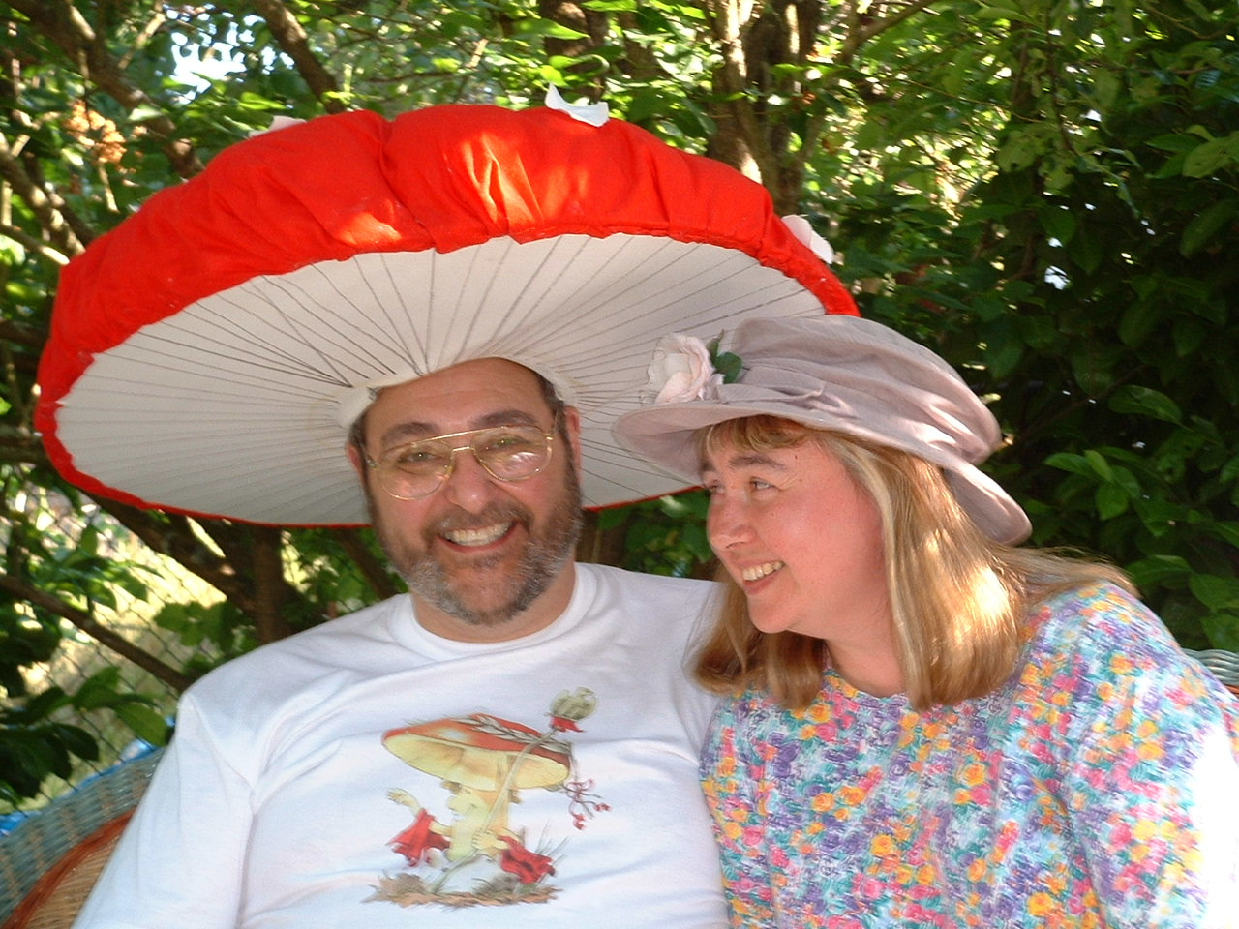

Bride (left) and 'Shroom (right)

